**Challanged: Đinh Hoàng Sáng**

**ID: BEBEIU17022**

Result

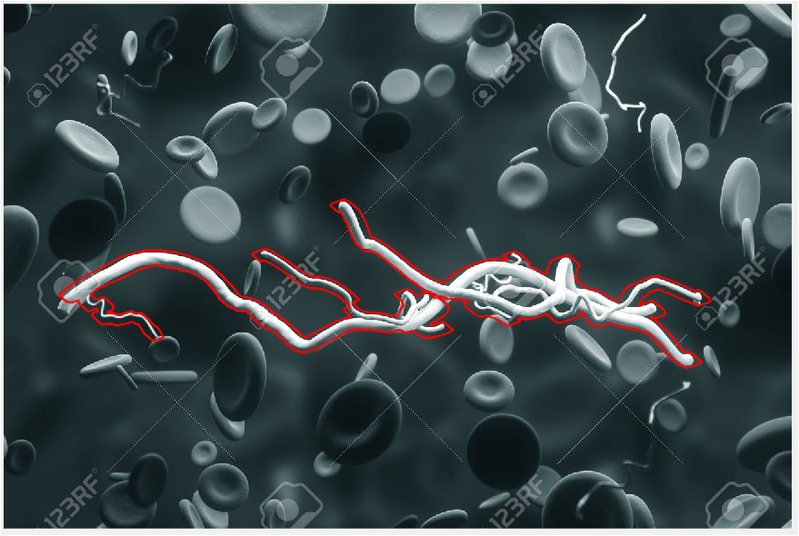

Code

clc

close all

clear all

%%Auto clear

I = imread('111.jpg');

%Show original image

figure,imshow(I),impixelinfo

gray=rgb2gray(I);

%Show index

figure,imshow(gray),impixelinfo

%pull hist to left(dark)

f2=gray-40

figure,imshow(f2)

%pull 'binary' image

E=150;

m=190;

g = 1./(1 + (m./(double(f2) + eps)).^E) ;

figure

imshow(g)

%denoise

g = imbinarize(g);

g = bwareaopen(g,5);

figure,imshow(g)

%expand

se90 = strel('line', 20, 2000);

se0 = strel('line', 20, 1400);

BWsdil = imdilate(g, [se90 se0]);

figure, imshow(BWsdil)

%Fill

BWdfill = imfill(BWsdil, 'holes');

figure, imshow(BWdfill);

%denoise

g = bwareaopen(BWdfill,1000);

figure,imshow(g),impixelinfo

%%link 2 block

for i=570:580

for j=490:500

g(j,i)=1;

end

end

%%

figure,imshow(g),impixelinfo

%%

[B,L] = bwboundaries(g,'noholes');

stats = regionprops(L,'Area','Centroid');

%%draw cover

figure,imshow(I);

hold on;

for i = 1:length(B)

boundary =B{i};

plot(boundary(:,2), boundary(:,1),'r','LineWidth',2)

end

%%denoise again

g = bwareaopen(g,10000);

figure,imshow(g),impixelinfo

%%

figure,imshow(g),impixelinfo

%%got B

[B,L] = bwboundaries(g,'noholes');

stats = regionprops(L,'Area','Centroid');

%%draw cover 2

figure,imshow(I);

hold on;

for i = 1:length(B)

boundary =B{i};

plot(boundary(:,2), boundary(:,1)+5,'r','LineWidth',2)

end